**UI/UX Minor Project**

**Task 1- User Journey Map**

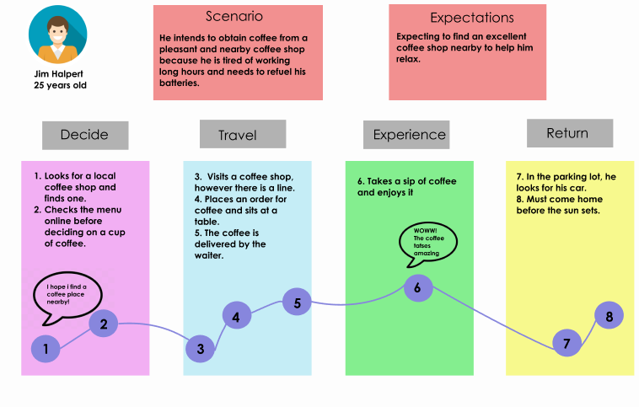

**Task 2- Mobile Login screen UI using Figma**

